**FOP 1 – Lab 7 Worksheet**

1. Do all exercises and examples from the lecture notes (this should be done at home, before attending the lab).
2. Write a program that repeatedly prompts the user to enter words and then outputs the number of words that contains the letter ‘k’ and the number of words that contain the letter ‘w’; input taking stops when the user enters ‘no more’. The program must use a break statement to exit the loop.
3. Write a program that displays the sum and the product of all odd numbers between a and b inclusively, where a and b are integers inputted by the user (you can assume that a is always less than b).
4. Write a program to print a triangle of asterisks as follows; you need to write 2 implementations: one using a single loop, the other using nested loops.

*

* *

* * *

* * * *

1. Write a program that prints a multiplication table, like this:

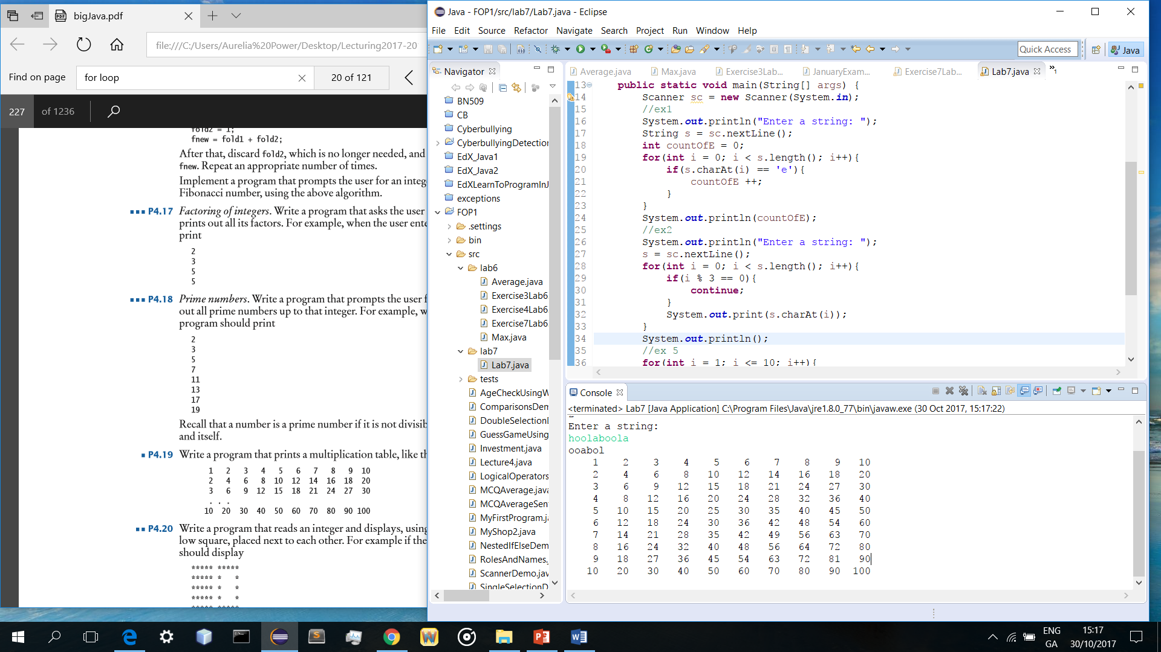

1. Write a program that uses for nested loops to print a pattern of asterisks as follows:

* * * *

* * * *

* * * *

* * * *

* * * *